Newsletter
  - Fall 2017

New Employability lab  TCAP Warren  TCTC Aspire and TCAP have partnered to create an employability lab that is open to the public Tuesday, Wednesday, and Thursdays from 9:00 am to 12:00 pm at TCAP Warren West Community Center on Palmyra Road in Warren. Visitors are able to explore careers, write a resume, and practice interviewing while getting personalized attention from an Aspire instructor. The new employability lab is free and open to the public to utilize for job search needs. For more information, call the Aspire office at 330-847-0503, extension 1611.  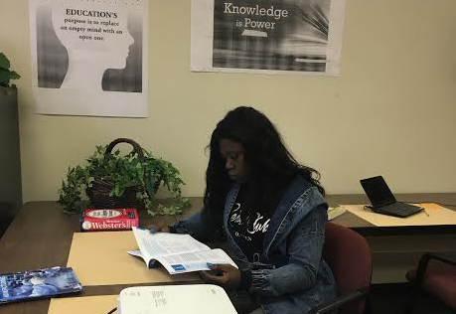  Career Tuesday  TCTC Aspire will hold the next Career Tuesday speaker series on Tuesday, November 28, 2017 at American National University. Windsor House will be coming to speak to students about careers in the healthcare industry. Students are encouraged to come and bring family and friends for this career education event. | Individual highlights  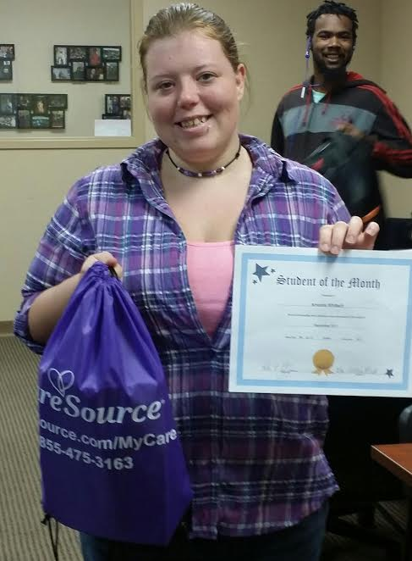  Student of the Month  Aspire Student of the Month for September is Amanda Whitlach! Amanda attends the American National University Aspire site. She has demonstrated a commitment to the Aspire program and meeting her educational goals. She has exemplary attendance and is focused on learning. Amanda is a positive role model to the other students and starts each day with a positive attitude! Congratulations Amanda! Keep up the good work!!  Meet the staff  Rachel Knowlton is the new Career Pathways Mentor for TCTC Aspire as well as a teacher at the ETI classroom. Rachel was a high school social studies teacher before joining the program three years ago as a teacher at the ETI site. Career pathways is a new part of the Aspire and Rachel is helping students explore their own skills as well as careers in order to set goals for themselves. Students will see Rachel during orientation and again in the classroom to support career education.
Partner Feature  YouthBuild USA is a longstanding national non-profit organization that supports 200 local programs, including Trumbull County in downtown Warren. Participants in YouthBuild are provided an opportunity to work toward their GED in an Aspire classroom or High School Diploma while learning a variety of construction skills by building affordable housing for low-income families. YouthBuild provides students the chance to earn income as well as opportunities for monthly incentives. Local director April Platt describes the program as a second chance for youth to change their situation, gain marketable skills, and become a leader in their community while being paid. Though YouthBuild classes and hands on experiences, students earn nationally accredited certifications including NCCER, OSHA, and RRP as well as develop good work habits, dedication, conflict resolution, and goal setting skills. To be eligible for YouthBuild, students must be between 16 and 24 years of age, enroll in Aspire or High School Diploma program, and go through intake application and interview. For questions or more information, please contact 330-306-5007. | Trumbull County Aspire Sites  TCTC Adult Training Center - Room AE163  528 Educational Highway  Warren, OH 44483  Monday thru Wednesday 9:00am-12:00pm  Monday thru Wednesday 6:00pm-9:00pm  ETI Technical College - Room 6  2076 Youngstown-Warren Road  Niles, OH 44446  Monday thru Wednesday 6:00pm-9:00pm  T-CAP (RISE) Program  Warren West Community Center  1230 Palmyra Road SW  Warren, OH 44485  Tuesday thru Thursday 9:00am-12:00pm  American National University - Room 103  (Formerly National College)  3487 Belmont Avenue  Youngstown, OH 44505  Monday thru Wednesday 9:00am-12:00pm  Ohio Means Jobs—Trumbull County - Room 109  280 N. Park Avenue  Warren, OH 44481  Monday thru Thursday 9:00am-12:00pm  Trumbull County Take Flight  (Former Warren Family Mission Building)  222 East Market St.  Warren, OH 44481  Monday thru Thursday 9:00am-12:00pm  Warren Center  261 Monroe St.  Warren, Ohio 44481  Tuesday thru Thursday 5:30pm - 8:30pm  Trumbull Homes  1970 Hazelwood  Warren, Ohio 44484  Monday thru Wednesday 1:00pm - 4:00pm  - Distance Learning Classroom attendance and regular login required.

